**Assignment 11 – Kubernetes Test Questions 2**

Date: 9 May 2024

Name: Mohamad Haffiz Bin Mohd Hissham

**Questions:**

1.

Create a pod **called test-pod** in the **"custom" namespace** belonging to the test environment (**env=test**) and backend tier (**tier=backend**). Use the **NGINX image** with version **1.17**.

2.

**Retrieve** the node named **node01** in **JSON format** and store it in a file **named /node-info.json**.

3.

Use **JSON PATH query** to **retrieve** the **osimages** of all the nodes and **store it** in a file named "**all-nodes-os-info.txt**" at the **root location**.

**Question 1:**

1. Create **custom** **namespace**, **kubectl create namespace custom**
   1. 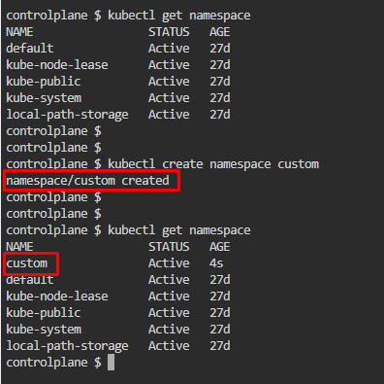
2. Create a YAML file as per outlined by question,
   1. **kubectl run test-pod --image=nginx:1.17 -n custom -l env=test --dry-run=client -o yaml > q1.yml**
   2. 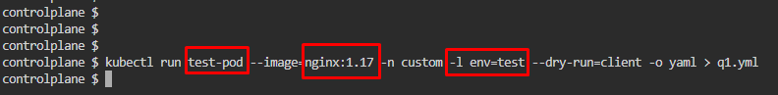
3. Edit YAML file created, **nano q1.yml**. Add another label **tier=backend**, Save and exit.
   1. 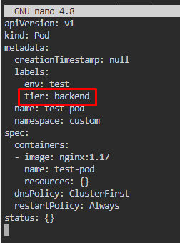
4. Deploy the YAML script, **kubectl apply -f q1.yml**. Then check created pod, **kubectl get pods -A** or **kubectl get pods -A**
   1. 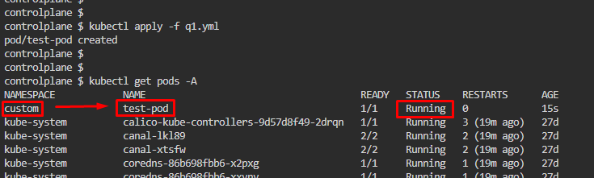

**Question 2:**

1. Run a command to get a node01’s info and store it as a JSON file, **kubectl get node node01 -o json > node-info.json**
   1. 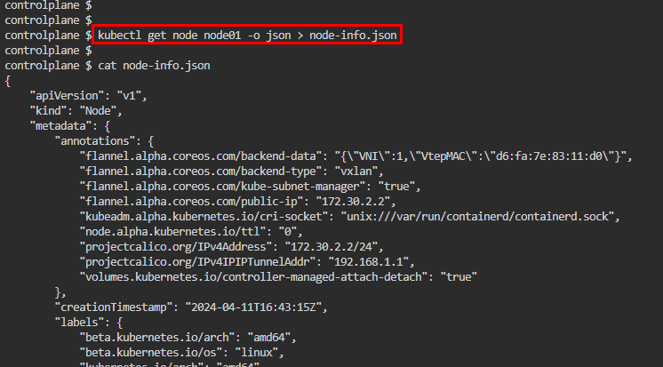

**Question 3:**

1. We need to use **JSON PATH query** to find nodes’ OS image
2. Refer to **Viewing and finding resources** section on [Kurbenetes’ Quick Reference document](https://kubernetes.io/docs/reference/kubectl/quick-reference/#viewing-and-finding-resources).
   1. Modify the command as applicable. Refer to [this JSON PATH](https://kubernetes.io/docs/reference/kubectl/jsonpath/) guide for more information
   2. A screenshot of a computer program

      Description automatically generated
3. Change **kubectl get nodes -o jsonpath='{.items[*].status.addresses[?(@.type=="ExternalIP")].address}'** to:
   1. kubectl get nodes -o jsonpath='{.items[*].status.nodeInfo.osImage}' > /all-nodes-os-info.txt
   2. Follow the proper notation
      1. **A computer screen shot of a computer program

         Description automatically generated**
4. Display the txt file created to get OS Image, cat /all-nodes-os-info.txt
   1. A screen shot of a computer

      Description automatically generated